
Department of Computer Science and Engineering
Course Code & Name | CSA06 – Design and Analysis of Algorithms
Assessment | CO1 – Assessment Tool 1: IT Application-Based Problem Solving – Scalability Audit of an E-Commerce Platform
Course Outcome Assessed | Determine algorithm efficiency using asymptotic notations and mathematical techniques including Master Theorem and substitution method.
Duration | 3 Days
Mode | Individual
Student Reg. No. | 192521241
Student Name | D.Padmasree

Instructions: Answer all parts. Show the basic operation, every step of each derivation and the final asymptotic result, and interpret what each result means for the platform. Assume the platform’s servers execute 10⁸ basic operations per second.
IT APPLICATION-BASED PROBLEM
Scenario – Scalability Audit of “ShopSphere”, an Online Shopping Platform: ShopSphere is a growing e-commerce platform whose product catalogue currently holds n = 100,000 products and is expected to reach n = 1,000,000 within a year. Before the expansion, the CTO has asked you, as the platform’s algorithm engineer, to audit five back-end modules, predict how each will behave as n grows, and recommend which modules must be redesigned. The modules are described below.
Module M1 – Duplicate-Listing Detector: Sellers sometimes upload the same product twice. Every night, the following routine compares every product with every later product.
FOR i ← 0 TO n − 2 DO
FOR j ← i + 1 TO n − 1 DO
IF Product[i].title = Product[j].title AND Product[i].seller = Product[j].seller THEN
MarkDuplicate(j)
END IF
END FOR
END FOR

Module M2 – API Rate Limiter: The public API audits request windows of doubling size using the routine below. A team member claims that it is Θ(n log n) because the outer loop runs about log n times and the inner loop runs up to n times.
i ← 1
WHILE i < n DO
FOR j ← 0 TO i − 1 DO
Audit(Request[j]) // basic operation
END FOR
i ← i × 2
END WHILE

Module M3 – Product Search: Two versions exist. Version S1 scans the unsorted catalogue sequentially until the product is found. Version S2 searches a sorted product index by comparing the key with the middle entry and discarding half the index after each comparison; its comparison count satisfies T(n) = T(n/2) + 1, T(1) = 1.
Module M4 – Recommendation Engine: The engine splits the customer–product data into four parts of size n/2 (because of replicated partitions) and merges the partial results in linear time: T(n) = 4T(n/2) + n. A proposed redesign removes the replication, giving T(n) = 2T(n/2) + n.
Module M5 – Sales Analytics Engine: The analytics engine splits the sales data into halves recursively and sorts the records by revenue at every level, giving T(n) = 2T(n/2) + n log n. Separately, profiling shows that the nightly report generator performs f(n) = 3n² + 10n log₂ n + 50 operations.
(a) Understand the Problem: For each of the five modules, identify the input size and the basic operation that dominates the running time, explain where it occurs, and state how you expect its execution count to grow as n increases. Justify each choice briefly.
(b) Analyse the Iterative Modules: For M1, derive the exact number of comparisons as a function of n and state the time and space complexity. For M2, derive the exact number of Audit operations, decide whether the team member’s Θ(n log n) claim is correct and give the tight bound. Verify your M2 result for n = 1,024.
(c) Solve a Recurrence by Substitution: Solve the recurrence for search version S2 using backward substitution, showing every intermediate step, and derive the exact closed form. State the time complexity and the space complexity of both an iterative and a recursive implementation.
(d) Apply the Master Theorem: For M4, apply the Master Theorem to both the current design and the proposed redesign, clearly identifying a, b, f(n), n^(log_b a) and the case used, and explain what happens to the running time when the data doubles. For M5, determine whether any of the three standard cases applies to T(n) = 2T(n/2) + n log n; if not, derive the complexity using the extended Master Theorem or a recursion tree.
(e) Analyse Best, Average and Worst Cases: For search versions S1 and S2, identify the input condition that produces the best, average and worst case and give the number of comparisons in each. For S1, derive the average number of comparisons when the probability that the searched product exists is p, and evaluate it for n = 1,000,000 and p = 0.5.
(f) Prove an Asymptotic Bound: Using the formal definitions, prove that the report generator’s cost f(n) = 3n² + 10n log₂ n + 50 is Θ(n²) by finding constants c₁, c₂ and n₀, and show that f(n) is not O(n).
(g) Scalability Decision: Estimate the number of basic operations and the running time of M1, M2, S2, M4 (both designs) and M5 for n = 1,000,000. Identify the modules that will fail to meet a nightly processing window of 10 minutes, and recommend, with justification, which modules must be redesigned and how.
Rubrics – Application-Based Question
Criteria | Weightage (%) | Level 4 – Exemplary | Level 3 – Proficient | Level 2 – Developing | Level 1 – Beginning
Understanding of Problem Context | 20 | Clearly understands the problem and accurately identifies all requirements | Good understanding with minor gaps | Basic understanding; some requirements unclear | Poor understanding or misinterpretation of the problem
Application of Concepts | 30 | Accurately applies appropriate concepts to solve complex problems | Applies relevant concepts correctly with minor errors | Applies basic concepts with limited accuracy | Fails to apply appropriate concepts
Problem-Solving Approach | 20 | Logical, well-structured, and efficient approach | Mostly logical approach with minor gaps | Basic approach with some inconsistencies | Illogical or unclear approach
Accuracy of Solution | 20 | Completely correct solution with proper justification | Mostly correct with minor errors | Partially correct solution | Incorrect or incomplete solution
Clarity | 10 | Clear, well-organized, and properly explained solution | Understandable with minor clarity issues | Limited clarity and explanation | Poorly presented and difficult to understand

Mark Evaluation:
Criteria | Weightage (%) | Level 4 – Exemplary | Level 3 – Proficient | Level 2 – Developing | Level 1 – Beginning
Understanding of Problem Context | 20
Application of Concepts | 30
Problem-Solving Approach | 20
Accuracy of Solution | 20
Clarity | 10
Total Marks

Code of Conduct
I D.Padmasree(192521241) (Name / Reg. No.) certify that this submission is my original work and that I have adhered to the guidelines specified for this assessment. I understand that any violation of academic integrity rules will result in disciplinary action.
Signature of the Student: D.Padmasree Date: 12/10/2026
(a) Understand the Problem:

1. Input Size and Basic Operations
The input size (n) represents the number of products in the ShopSphere catalogue.
Module | Basic operation | Where it occurs | Expected growth
M1 – Duplicate Detector | Compare product titles and sellers | Inner loop | (O(n^2))
M2 – API Rate Limiter | Audit a request | Inner loop | (O(n))
M3 – Search S1 | Compare product with search key | Sequential scan | (O(n))
M3 – Search S2 | Compare key with middle entry | Binary search | (O(log n))
M4 – Recommendation | Merge partial results | Recursive processing | Depends on design
M5 – Sales Analytics | Sort and process records | Recursive sorting | (O(nlog^2 n))

2. Explanation
- M1: Every product is compared with every later product. The number of comparisons grows quadratically.
- M2: The loop doubles \(i\) in each iteration, while the total number of audits forms a geometric series.
- M3 S1: Products are checked one by one until the required product is found.
- M3 S2: The sorted index is divided into halves after every comparison, reducing the search space quickly.
- M4: The current design processes four recursive subproblems, while the redesign processes only two.
- M5: Recursive processing and \(n\log n\) work at each level produce a higher complexity than ordinary merge sort.
Conclusion: M1 and M5 need careful scalability analysis. M4's redesign should improve performance, while M2 and S2 are more scalable.
(b) Analyse the Iterative Modules

1. M1 – Duplicate-Listing Detector
Number of comparisons:
[ C(n)=(n-1)+(n-2)+cdots+1 ]
[ C(n)=frac{n(n-1)}{2} ]
For (n=1,000,000):
[ C(n)=frac{1,000,000(999,999)}{2} ]
[ boxed{C(n)=499,999,500,000}]
- Time Complexity: (Theta(n^2))
- Space Complexity: (O(1))

2. M2 – API Rate Limiter
Audit operations:
[ A(n)=1+2+4+cdots+2^{k-1}]
[ A(n)=2^k-1,quad k=lceil log_2 nrceil]
Therefore,
[ boxed{A(n)=Theta(n)}]
The team's (Theta(n log n)) claim is incorrect.
Verification for (n=1024):
[ A(1024)=2^{10}-1 ]
[ boxed{A(1024)=1023 text{ audits}} ]
Conclusion: M2 has linear time complexity and is more efficient than M1.

(c) Solve a Recurrence by Substitution – M3 S2
Given:
[ T(n)=T(n/2)+1quad T(1)=1 ]
Substitution:
[ T(n)=T(n/4)+2 ]
[ T(n)=T(n/8)+3 ]
After (k) steps:
[ T(n)=T(n/2^k)+k ]
At the base case, (n/2^k=1), so (k=log_2n).
Therefore,
[ boxed{T(n)=1+log_2n} ]
- Iterative binary search: Time (Theta(log n)), Space (O(1)).
- Recursive binary search: Time (Theta(log n)), Space (O(log n)).
Result: Binary search is efficient for large product catalogues.

d) Apply the Master Theorem
1. M4 – Current Design
[ T(n)=4T(n/2)+n ]
(a=4, b=2,f(n)=n)
[ n^{log_2 4}=n^2 ]
Case 1 applies.
[ boxed{T(n)=Theta(n^2)} ]
When data doubles, running time becomes approximately 4 times.
2. M4 – Proposed Design
[ T(n)=2T(n/2)+n ]
(a=2, b=2, f(n)=n)
[ n^{log_2 2}=n ]
Case 2 applies.
[ boxed{T(n)=Theta(n log n)} ]
When data doubles, running time becomes approximately 2 times.
3. M5 – Sales Analytics
[ T(n)=2T(n/2)+n log n ]
(a=2,b=2,f(n)=n log n )
[ n^{log_2 2}=n ]
Using the extended Master Theorem:
[ boxed{T(n)=Theta(n log^2 n)} ]
Conclusion: The proposed M4 design is more efficient, and M5 scales better than quadratic algorithms.

(e) Analyse Best, Average and Worst Cases
1. S1 – Sequential Search
- Best case: Product is first; comparisons = (1).
- Average case: Product exists; comparisons = (frac{n+1}{2}).
- Worst case: Product is last or absent; comparisons = (n).
Average comparison formula:
[ E[C]=n-frac{p(n-1)}{2} ]
For (n=1,000,000, p=0.5):
[ E[C]=1,000,000-frac{0.5(999,999)}{2} ]
[ boxed{E[C]=750,000.25} ]
2. S2 – Binary Search
- Best case: Middle element; (1) comparison.
- Average case: (O(log n)).
- Worst case: (O(log n)), approximately 20–21 comparisons for (n=1,000,000).
Conclusion: Binary search is faster than sequential search for a large, sorted catalogue.

(f) Prove an Asymptotic Bound
Given:
[ f(n)=3n^2+10n log_2n+50 ]
Lower bound:
[ f(n) ge3n^2 ]
Choose (c_1=3).
Upper bound: Since (log_2nle n) for (n ge1),
[ f(n) le3n^2+10n^2+50n^2 ]
[ f(n) le63n^2 ]
Choose (c_2=63, n_0=1).
Therefore,
[ 3n^2 le f(n) le63n^2 ]
[ boxed{f(n)=Theta(n^2)} ]
To prove (f(n) notin O(n)):
Assume (f(n)le Cn). Since (f(n)ge3n ^2),
[ 3n^2 le Cn Rightarrow3n le C ]
This is impossible for arbitrarily large (n).
[ boxed{f(n) notin O(n)} ]
Conclusion: The report generator has quadratic growth and requires optimization.

(g) Scalability Decision
The server executes \(10^8\) basic operations per second, and the nightly processing window is 10 minutes.
Convert the available time into operations:
10 minutes=600 second
Maximum operations =600 times10^8
6*10 operations
Any module requiring more than 60 billion basic operations exceeds the available window under this simplified model.

1. Estimates for \(n=1,000,000\)
Running times assume the stated operation rate and exclude I/O, network, database, and other system overhead. For recursive algorithms, asymptotic estimates are not exact operation counts.
Note: The M4 and M5 timings are illustrative estimates based on their dominant terms, not exact measured runtimes. The recurrence base costs and operation constants are not supplied. M4's current design has quadratic growth, so its exact runtime depends on those constants.

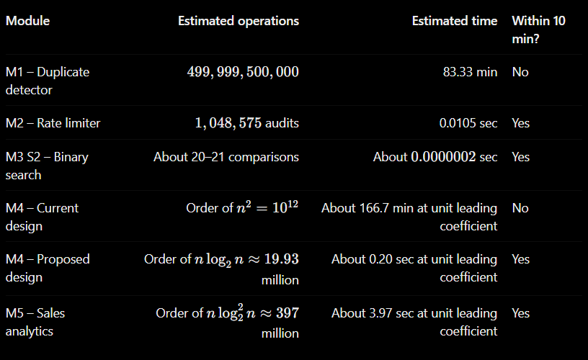
2. Nightly Report Generator
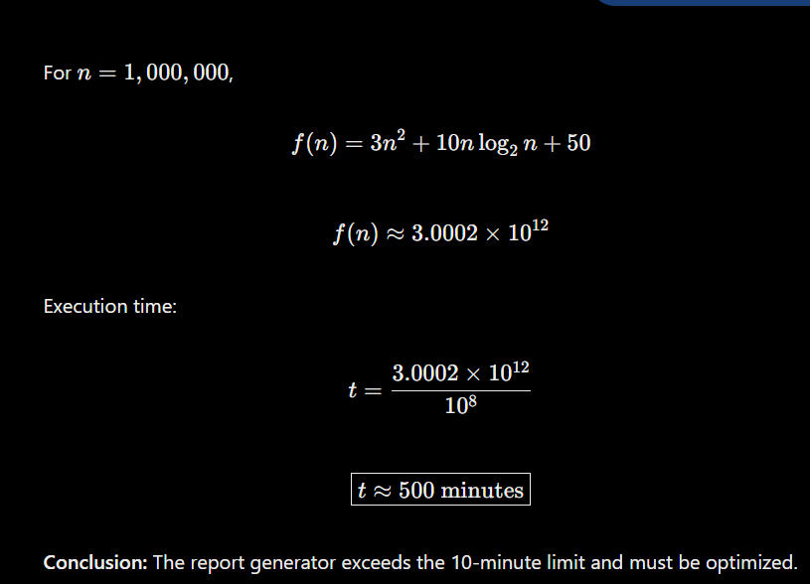

3. Scalability Audit Summary
M1 – Duplicate-Listing Detector
The estimated comparison count exceeds the operation budget. Replace pairwise comparison with a hash-based grouping approach using the product title and seller as the key. Expected time becomes \(\Theta(n)\), assuming good hashing.
M2 – API Rate Limiter
The audit count is linear. Keep the doubling-loop implementation and verify it with load testing.
M3 S2 – Product Search
Binary search is efficient. Maintain a sorted product index and use iterative binary search where possible to reduce auxiliary memory.
M4 – Current Recommendation Engine
The quadratic design is not scalable. Remove unnecessary replication and adopt the proposed \(\Theta(n\log n)\) design.
M5 – Sales Analytics Engine
The complexity is \(\Theta(n\log^2 n)\). The dominant-term estimate fits the 10-minute window, so immediate redesign is not required based on this model alone. Monitor actual runtimes and optimize repeated sorting if needed.
Nightly Report Generator
Its quadratic cost exceeds the processing budget. Optimize the calculation, reduce repeated work, and consider incremental report generation.

4. Final Recommendation
The modules that must be redesigned first are M1, M4 (current design), and the nightly report generator. Their estimated operation counts exceed the 10-minute budget under the stated model.
M2 and M3 S2 should be retained because their growth rates are efficient. M5 can remain provisionally, subject to performance testing and optimization of repeated sorting.
The audit shows that choosing efficient algorithms is essential for ShopSphere to grow from 100,000 to 1,000,000 products without missing its nightly processing deadline.

Conclusion
The scalability audit demonstrates the importance of asymptotic analysis in selecting algorithms for large e-commerce platforms. M1 performs quadratic comparisons, M2 has linear growth, and binary search achieves logarithmic growth. The Master Theorem shows that redesigning M4 improves its complexity from \(\Theta(n^2)\) to \(\Theta(n\log n)\), while M5 has complexity \(\Theta(n\log^2 n)\). The report generator also has quadratic complexity and needs optimization. Therefore, ShopSphere should prioritize redesigning the quadratic modules, maintain efficient search and rate-limiting algorithms, and validate all estimates through actual performance testing.

